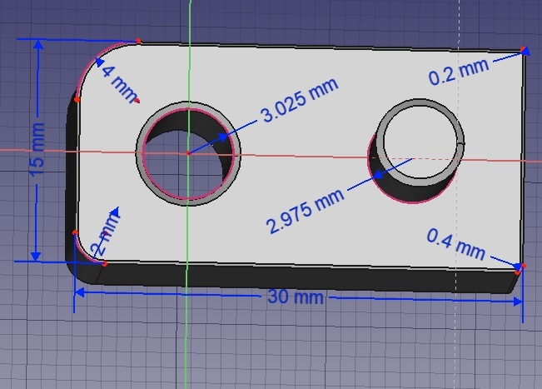

Altered Parameters  (Flow, Temp, Speed, Acceleration, Jerk, Fan speed, Flow rate compensation factor, expansion coefficient) | 15mm | 30mm | Ø3.025 | Ø2.975 | Corner radiuses
Altered Parameters  (Flow, Temp, Speed, Acceleration, Jerk, Fan speed, Flow rate compensation factor, expansion coefficient) | 15mm | 30mm | Ø3.025 | Ø2.975 | Corner radiuses

