Activity 1.2.3 Electrical Circuits – Physical

Introduction
Since the late 1800s, engineers have designed systems to utilize electrical energy due to its ability to be converted, stored, transmitted, and reconverted efficiently into other forms of energy. In the 21st century, electrical energy production, distribution, and application have become consumer driven. Today’s consumer utilizes electrical energy in all aspects of life, from cell phones and computers to refrigeration and heating and cooling systems, and even transportation. Electrical energy, depending on geographic location, is converted from mechanical energy, chemical energy, light energy, and thermal energy before it reaches the consumer.

Regardless of the conversion process, electrical energy consists of three basic components: current, voltage, and resistance. Current is the net transfer of electric charge per unit of time. Voltage is the amount of work required to move a charge from one point to another. Resistance is the opposition to the flow of current. Understanding the relationship between current, voltage, and resistance allows engineers to design efficient, safe, and functional electrical circuits. Electrical circuits consist of the following components: an energy source to provide voltage, conductors to allow current travel, insulators to limit current travel, and a load. Electrical circuits provide an uninterrupted path for current travel and are broken into two distinct categories of design: series circuits and parallel circuits.

Equipment
- Engineering notebook
- Notes from the Breadboarding and Electronics presentation
- Variable power supply
- Breadboard
- 4 LED lamps
- 330-ohm resistors
- Hook-up wires (red and black)
- Digital multimeter
Procedure
This activity will provide you with an introduction to voltage, current, resistance, series circuits, parallel circuits, and Ohm’s Law. Your team will construct circuits using various electronic components. You will use a digital multimeter to measure properties within the circuit.
Introduction to Electric Circuits
Electric Circuit Schematics
Schematics are diagrams consisting of symbol representations and configurations of electrical components within a circuit. The table below illustrates circuit symbols to be used within schematics throughout this lab.
Symbol | Pictorial | Component
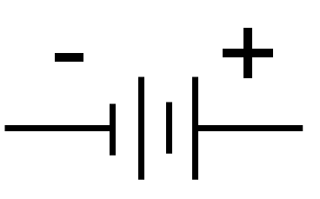 | 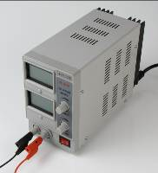 | Power supply
 | 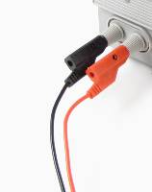 | Conductive wire  (Single wire, flat plug)
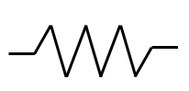 | 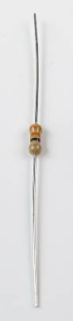 | Resistor
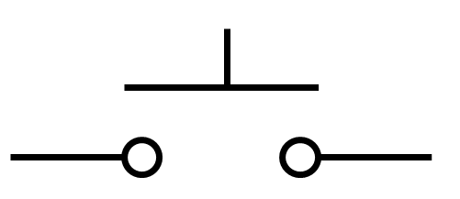 | 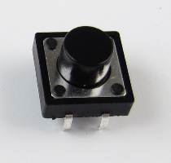 | Push button switch
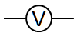 | 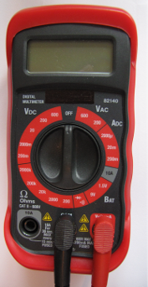 | Voltmeter  (Voltage readings)  V
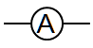 |  | Ammeter  (Current readings)  I
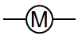 |  | Multimeter  (Resistance readings)  Ω
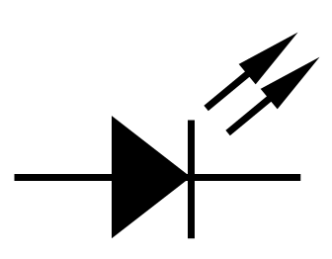 | 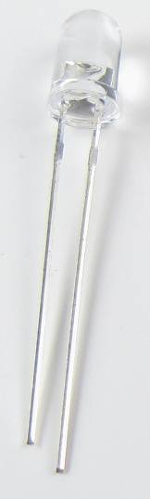 | LED

Ohm’s Law
The relationship between current, voltage, and resistance within an electrical circuit was developed by Georg Simon Ohm and is known today as Ohm’s law. Ohm’s law states that the direct current flowing in an electric circuit is directly proportional to the voltage applied to the circuit. In other words, an electric circuit represents the flow of electrons along a conductive pathway between two points. This flow of electrons is referred to as current. What causes the electrons to move? A motivation, or voltage, causes the electrons to flow. Voltage refers to the potential difference, or amount of work to be done to move a charge from one point to another along an electric circuit. While electrons continuously flow along a given circuit, opposition to their movement is referred to as resistance.

It is important to understand the mathematical equation for Ohm’s law. Use the Ohm’s law table provided to work through activity practice problems and lab calculations.
Ohm’s Law
Equation | Variables | Units | Unit Symbols
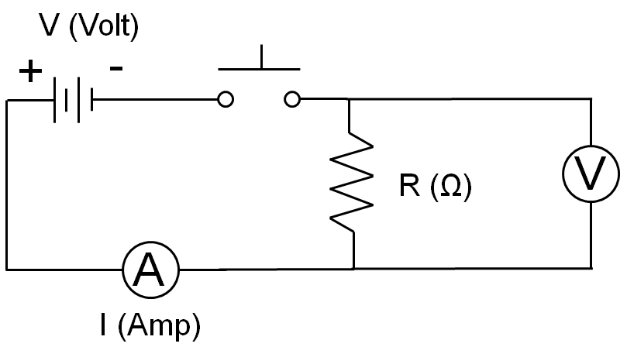

Practice Calculations
  - Draw the circuit schematic.
  - Identify the known and unknown values for each circuit.
  - Provide the appropriate unit for each measurement.
  - Show all steps for each calculation.

- On a camping trip, you decide to use a cordless air pump to inflate an inflatable mattress. If the air pump is powered by a 9-volt battery with a resistance of 18 ohms, what is the amount of current flowing through the circuit?
Circuit Schematic | Calculations

- A DJ uses a 110 volt outlet to plug in a strobe light. If the current flowing through the light is 0.050 amps, how much resistance is within the circuit?
Circuit Schematic | Calculations
- You finally found the MP3 player that you have wanted for months. While you are waiting in the checkout line, you read the back of the packaging. The manufacturer has guaranteed that the player will perform consistently with a resistance of 40 ohms and a current of 0.1 amps. What is the voltage for the MP3 player?
Circuit Schematic | Calculations

Constructing Circuits
Your team will construct a series and parallel circuit using the steps provided below.
Caution: Consult the user’s manual for your specific power supply. This procedure is based on the RSR Variable Power Supply, Model HY1802D. Adapt the procedure to the power supply in your classroom.

Creating a Simple Circuit
- Wire preparation
  - Cut a red and black section of the hook-up wire approximately 6 in. long.
  - Strip approximately 1/4 in. of wire insulation from each end of the wires.
- Connect the variable power supply to the breadboard.
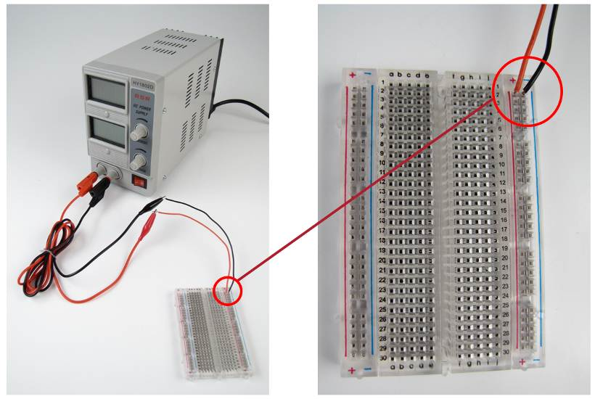
  - Ensure that the variable power supply is turned off.
  - Insert the 6 in. red hook of wire into the breadboard strip marked ‘+’. Insert the 6 in. black hook up wire into the breadboard strip marked ‘–’. Clip the positive and negative leads from the power supply to the same-colored hook-up wires. See the image above.
  - Turn the variable power supply on.
  - Turn the current dial fully clockwise so that the power supply will deliver a constant voltage.
  - Turn the voltage clockwise until the voltage display is 9 V.
  - Turn the variable power supply off.
- Construct the simple circuit displayed below using a 330-ohm resistor, diode, and a switch in the open position. You are to interpret the schematic diagram to create a circuit. Turn the variable power supply on. With the switch open, Measure the voltage across the power supply, across the 330-ohm resistor, and across the diode. Record the measurements in the space provided below.
Voltage across the power supply ______V
Voltage across resistor (with switch open) ______V
Voltage across diode (with switch open) ______V
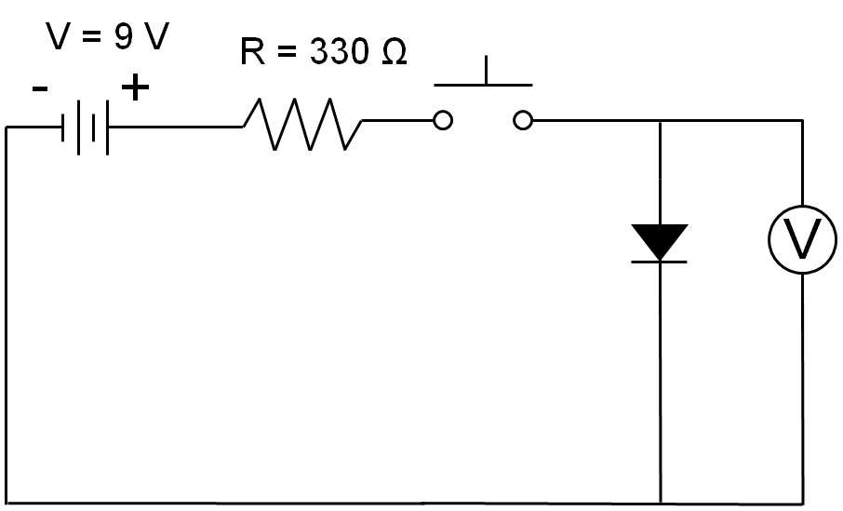 | 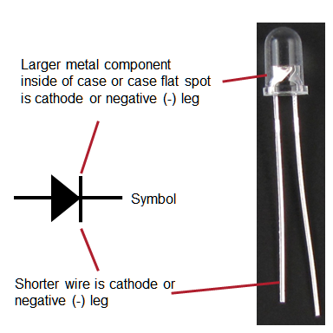
Circuit Schematic | Diode Bias
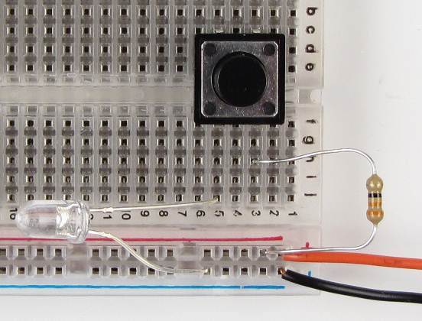 | 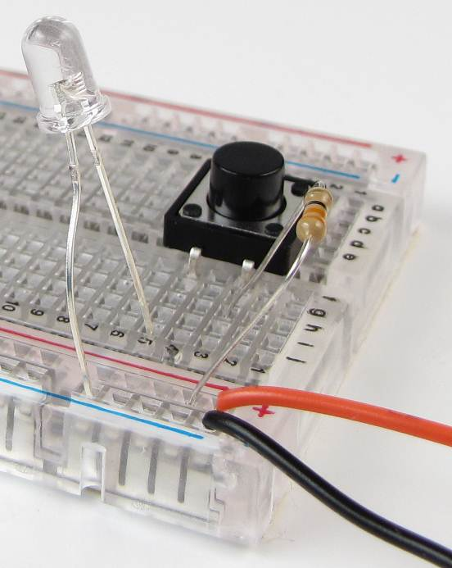
Physical Circuit | Physical Circuit
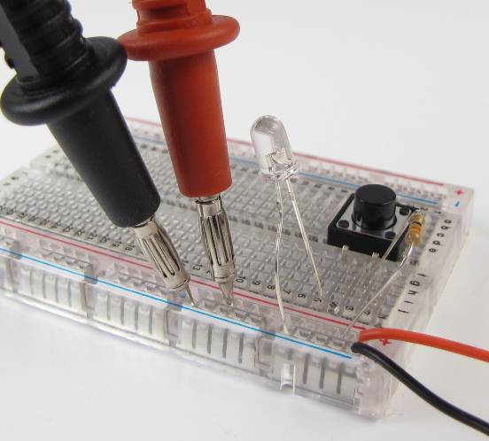 | 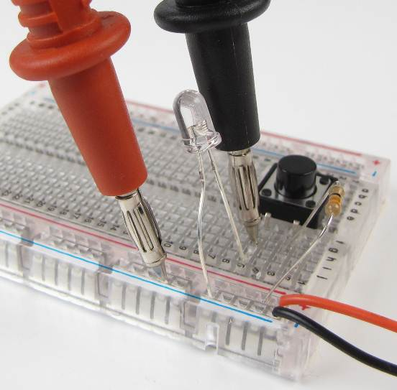
Power Supply Voltage Measurement | Diode Voltage Measurement
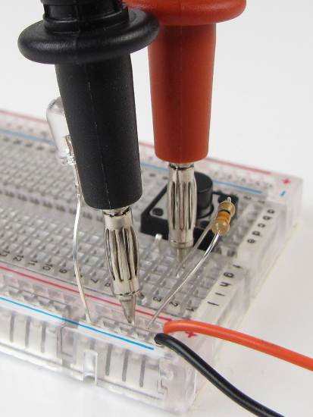
Resistor Voltage Measurement

- Close the switch so the diode turns on. Measure the voltage drop across the diode and across the resistor. Record the measurements in the space provided below. Leave the button pushed and note how the resistor voltage changes.
Voltage across resistor (switch closed) ______V
Voltage across diode (switch closed) ______V
How does the voltage across the resistor change during the first few seconds the LED is turned on?
- Record the current delivered by the power supply. Use the voltage (V) for the resistor in the previous step and the current (I) from the power supply to determine the resistance of the resistor. Show your work and include units. Verify the current with the multimeter.
Current (power supply display) ______ A
Current (multimeter) ______mA = ______A
Resistance of the resistor: Formula: ______
Substitute values: ______
Resistance = ______Ω

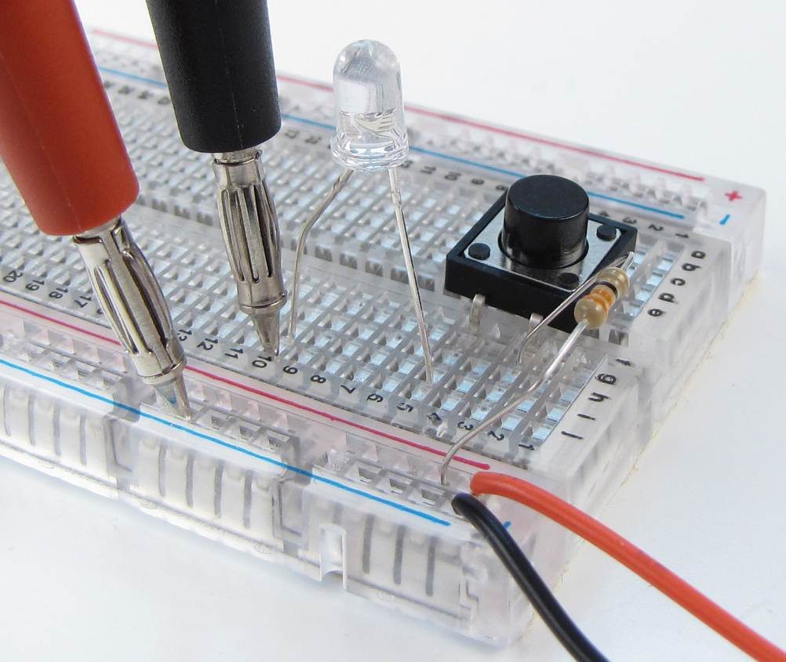
Current Measurement
Creating a Series Circuit
- Construct the series circuit displayed below using a 330-ohm resistor, two diodes, and a switch in the open position. You are to interpret the schematic diagram to create a circuit. Turn the variable power supply on. Measure the voltage across the power supply, across the 330-ohm resistor, and across each diode. Record the measurements in the space provided below.
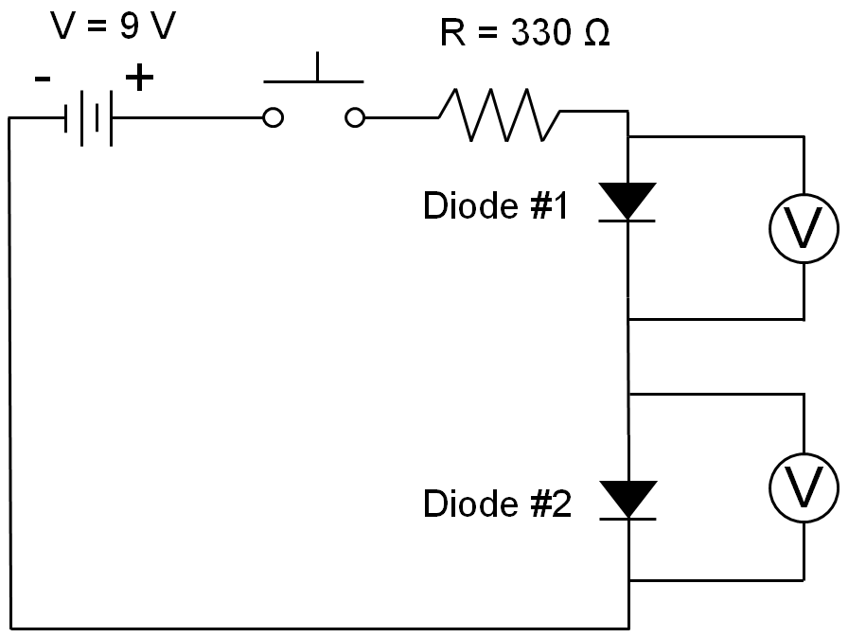
Circuit Schematic
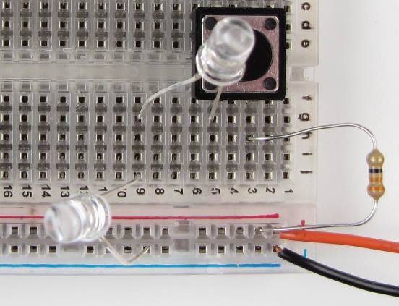 | 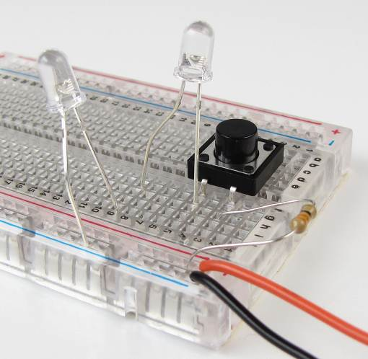
Physical Circuit | Physical Circuit
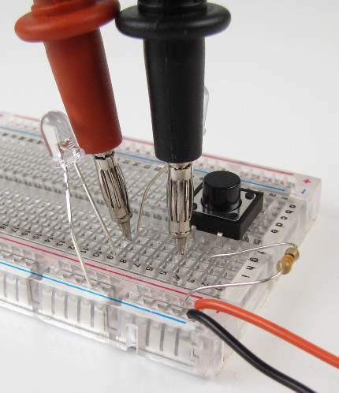 | 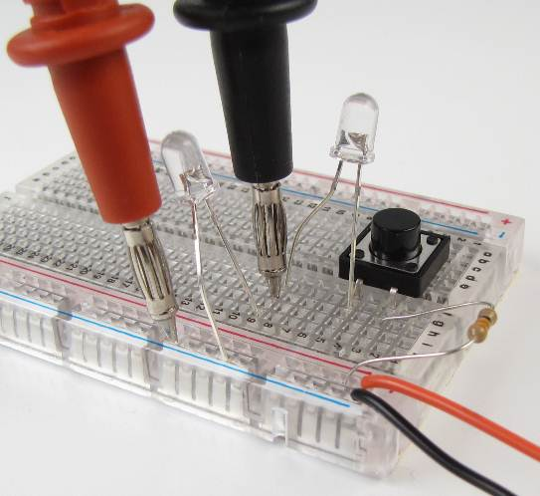
Diode #1 Voltage Measurement | Diode #2 Voltage Measurement

Measurements made with switch open:
Current from the power supply ______A
Voltage across power supply _____V
Voltage across 330-ohm resistor ______V
Voltage across diode #1 ____V Voltage across diode #2 ____V
- Close the switch. Record the new readings for the circuit.
Current from the power supply______A

Voltage across the power supply ______V

Voltage across 330-ohm resistor ______V

Voltage across diode #1 ______V
Voltage across diode #2 ______V
Total voltage across resistor and two diodes ______V
% difference of power supply voltage vs. total voltage drop across circuit=____%
- Add a multimeter between the diodes and record the current.

Current between diodes ______mA = ______A

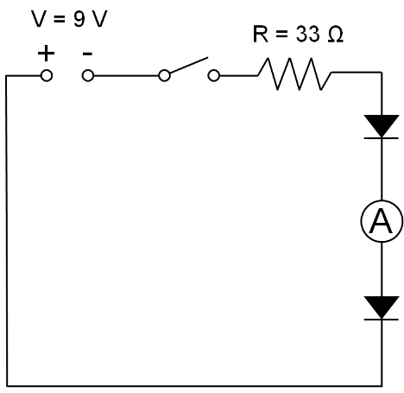 | 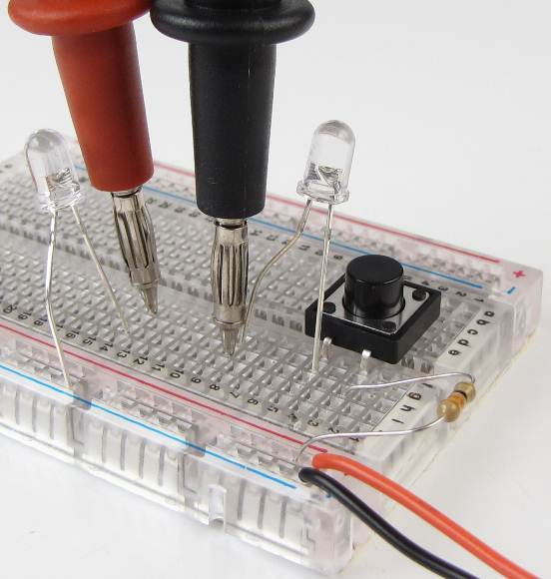
Circuit Schematic | Current Measurement
Creating a Parallel Circuit
- Create the circuit shown below. Be careful to avoid contacting the diode and resistor legs which will cause a circuit malfunction.
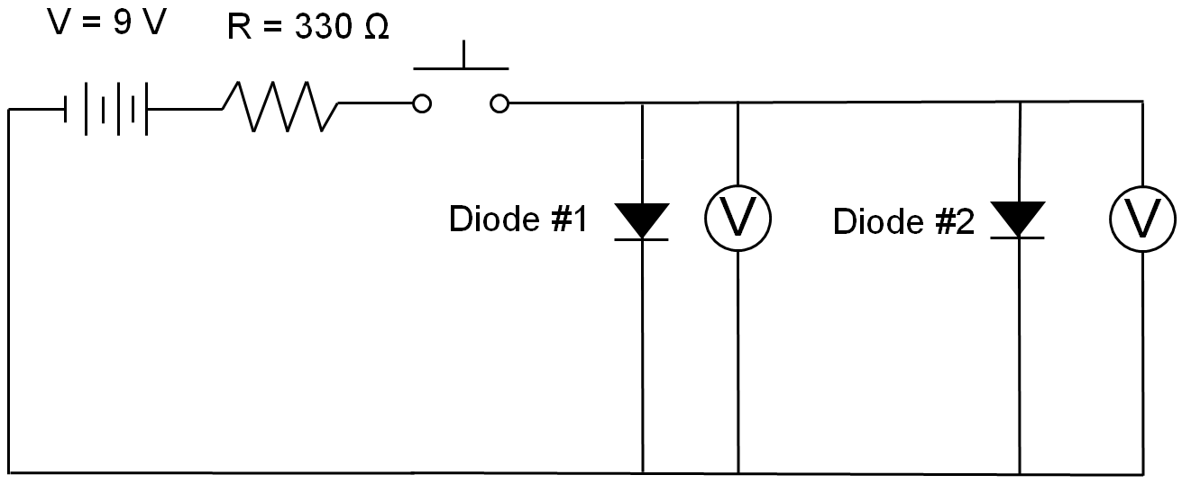
Circuit Schematic
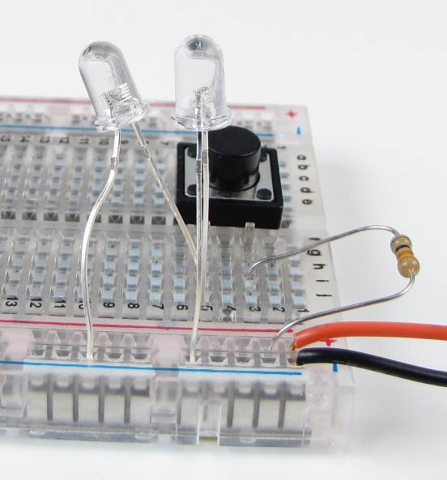 | 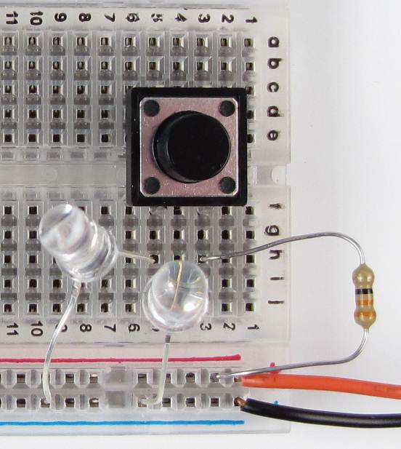
Physical Circuit | Physical Circuit

Voltage across power supply _____V Voltage across resistor ______V
Voltage across diode #1 ______V Voltage across diode #2 ______V
Total voltage across resistor and diode #1 ______V
Total voltage across resistor and diode #2 ______V
- Measure the current through each of the diodes.
Current through diode #1 ______mA = ______A
Current through diode #2 ______mA = ______A
Total of current through diode branches ______A
Current delivered by power supply ______A

Creating a Combination Circuit
- Create the circuit shown below. Be careful to avoid contacting the diode and resistor legs which will cause a circuit malfunction.
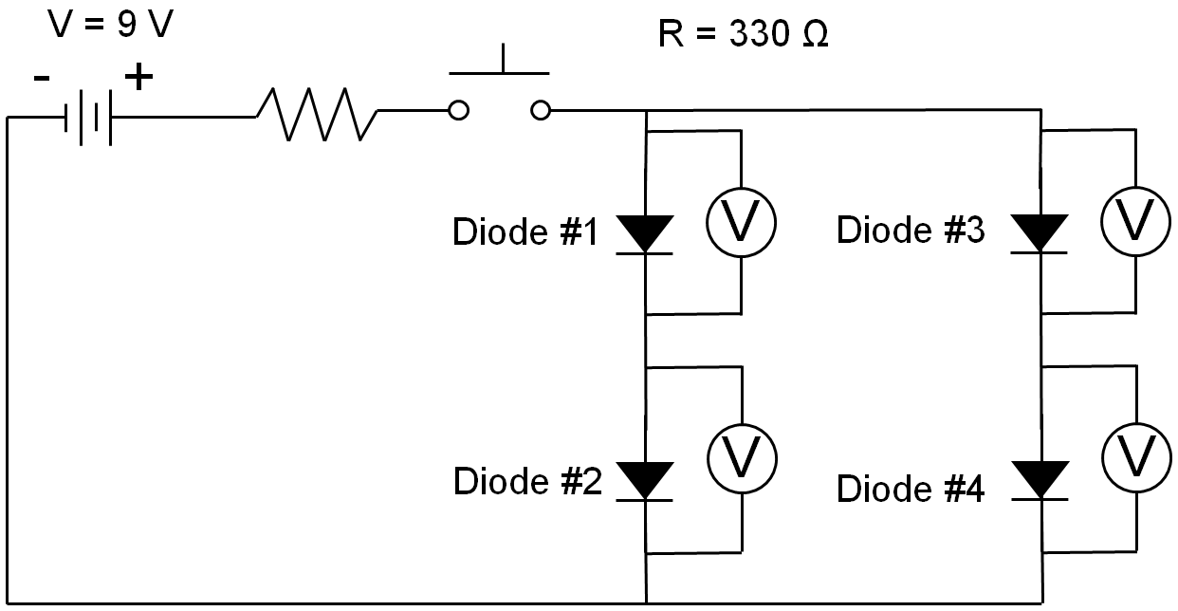
Circuit Schematic
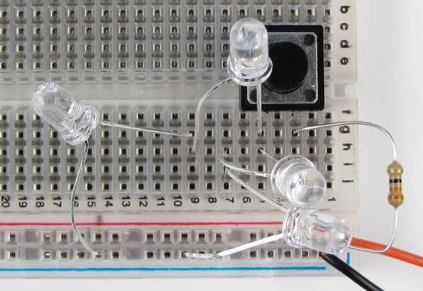 | 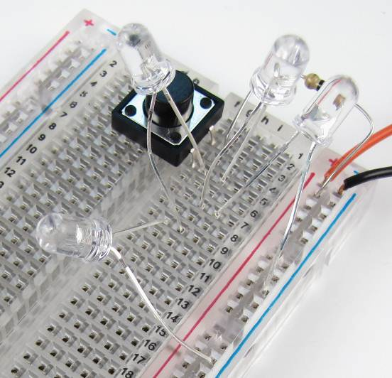
Physical Circuit | Physical Circuit

Voltage across power supply ______V
Voltage across resistor ______V
Voltage across diode #1 ______V Voltage across diode #2 ______V
Voltage across diode #3 ______V Voltage across diode #4 ______V
How does the voltage from the power supply relate to the other voltages?

Current through diode #1 and #2 ______mA = ______A
Current through diode #3 and #4 ______mA = ______A
Current through diode branches ______A
Current total from power supply ______A
Conclusion Questions
- Explain the difference between a series and a parallel circuit.

- Explain the difference between the voltage output at the battery and the voltage across each component in the series circuit. Explain the relationship between the current output at the power supply and the current through each component in the series circuit. Explain how your data support the relationships observed.

- Explain why the current is the same between the diodes as it is from the power supply in step 8.

- Explain the relationship between the voltage output of the power supply and the voltage across each diode in the parallel circuit. Explain the relationship between the current output of the power supply and the current through each diode in the parallel circuit. Explain how your data support the relationship observed.

- For the combination circuit, explain the relationship between the voltage output at the power supply and the voltage across the two paths. For the combination circuit, explain the relationship between the current output of the power supply and the current through each path in the parallel circuit. Explain how your data support the relationships observed.

